Ein Bild, das Essen, Zeichnung enthält.

**Thinking about joining teaching placements in York or Edinburgh? Come to the Q&A on November 21st at 16:30!**

**Teaching Placement in York – September 2024**

Ein Bild, das draußen, Wolke, Himmel, Baum enthält.

**Introduction (Lisa Zöhrer, Hannah Oberndorfer-Wagner, Eva Pernegger)**

As a group of 28 teacher trainees, we had the fantastic opportunity to participate in a two-week teaching placement in York. From the 14th to the 28th of September, we stayed in this beautiful, historic city in the north of England. Although York is relatively small, it’s rich in history, with picturesque streets and plenty to see and do.

We were either accommodated at Hedley House Hotel or with host families, all just a few minutes away from the schools we were placed in. The location was perfect – only about five minutes from the city center, which gave us plenty of chances to explore after school.

Our placements were at different schools in and around York, including St. Peter’s (with classes from ages 2-8, 8-13, and 13-18), Park Grove, Lakeside, Haxby Road, and Sir Robert Wilkinson. This allowed us to gain valuable insights into the daily routine in English schools and see firsthand how things differ compared to schools in Austria.

Outside of school, we had many opportunities to explore the local area. On the weekends, for example, we visited Goathland, Whitby, and Robin Hood’s Bay. Overall, it was a rewarding experience – both professionally and culturally – and we would highly recommend it to any future teacher trainees.

Below, you will find more detailed information about the accommodation options, the schools, and the excursions.

**Tasks as a teaching assistant Manuela, Felix**

Under the term “teaching placement in the UK” one should neither imagine that you can just sit in the back and purely observe, taking notes, nor that you have to teach all the time. Actually, we participated in class as teaching assistants, helping students as well as the teacher.

We got the chance to mainly follow one class through their typical school days, assisting where we could. As a teaching assistant at St. Peter's School, our tasks included supporting the classroom teacher by distributing learning materials, such as handing out worksheets and assisting students with tasks like pasting them into their books.

We provided individual help to students during lessons, particularly in subjects like Mathematics and English, ensuring they understood the material and stayed engaged. Additionally, we assisted the class teachers in managing the classroom by encouraging participation and offering support to students with special needs, ensuring that everyone could fully participate in the activities.

Our role was focused on creating a smooth and inclusive learning environment for both the teacher and students, which was not only helpful for the teacher but also highly engaging for us.

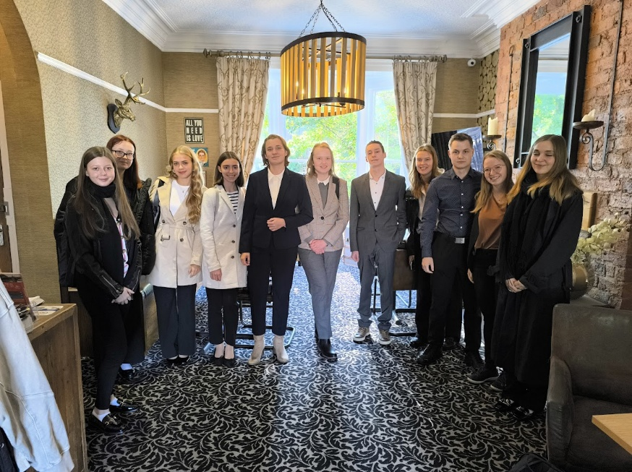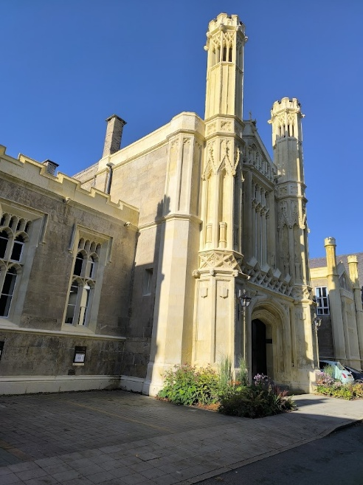

**St. Peter’s 8-18: general information (Stefanie Wageneder, Helen Holzleitner)**

St. Peter’s was founded in 627 AD and is said to be the 4th oldest school in the world. The school grounds are located near the city centre of York.

This private school is attended by children aged eight to 13, with each year group divided into three to four classes depending on the number of pupils. Also, pupils are required to wear school uniforms and are divided into houses, which are called Alcuin, Fairfax, York, Ainsty, and Elmet, to enhance learning in between classes and strengthen team spirit.

The school is well-equipped. For instance, every classroom has a smartboard in addition to a whiteboard which improves the quality of the lessons. Furthermore, the school offers art rooms with various supplies, a library, computer rooms for Information and Technology classes, science labs, music rooms, small recording studios, and rental instruments. In addition, there is a workshop space with different equipment and machines such as embroidery machines, sewing machines, stationery drills, and tools so that the students can get creative and create crafts from wood or textiles. The school also has various sports facilities such as rugby fields, swimming pools, a boathouse for rowing lessons, hard courts for field hockey and much more. The school also has a large dining room where a wide selection of food is freshly cooked for pupils and staff every day. Furthermore, there is always a warm main course as a meat option and a vegetarian option. In addition, there is a salad buffet and a buffet where other small hot and cold snacks are available. They offer soup and a dessert as well as sandwiches and fruits.

Every morning before school, pupils have to go to the chapel for morning prayers or participate in assemblies, depending on the day of the week.

After school, students can choose from a variety of clubs and activities, such as the drama club, sports clubs, or the art club, which are offered by teachers. In addition, they can take music lessons to learn an instrument.

In order to be allowed to complete our teaching placements at St. Peter's School, we had to hand in some documents, such as our birth certificates. These were then checked and confirmed during a security check. In general, student safety is a very important aspect of the school, as visitors, for example, also need to be registered before they are allowed to enter the building.

**St. Peter’s 8-13 Everyday school life / daily routine (Christina Voraberger, Josef Schmid)**

We were given the opportunity to join J3, where the students are ten to eleven years old. The students at junior school are mainly taught by one form teacher, who has their own classroom. During our stay at the school, we followed one class through their day. Now we would like to explain their daily routine in more detail.

Period 1 starts at 9.00 am, but the students have to be there at 8.15 am. This is because they attend chapel twice a week before Period 1. On Mondays and Wednesdays, they have house assembly. Like Hogwarts, all the kids are divided into five houses. This offers the opportunity for inter-grade learning. At the house assemblies, they discuss general topics and there is a focus on social learning. Every Friday, the whole school meets for a school assembly. Unlike the school in Austria, the students have to be in school till 4:00 pm every day and have a longer break at lunchtime.

After school they have the opportunity to take part in different after-school activities until around 5.30 pm. Examples of this are swimming, orchestra, drama or a dance club. It can be said that all the clubs and activities that we have in Austria are integrated into everyday school life. They even have the opportunity to learn instruments at school. For this, they are taken out of their regular classes and learn the content they have missed on their own. But also sporting talents are promoted. In addition to two sports lessons per week, the kids have games on two afternoons. During our stay, the girls played hockey, and the boys played rugby. Some of them even took part in competitions with other schools.

We had the impression that languages are also very important at St. Peter’s. In J3 they learn basics of French, German and Spanish. After this year they have to decide which of the three languages they want to learn. We were very impressed by the comprehensive and varied program that the school offers. We think it would be a great idea to integrate some of the subjects into Austrian schools as well. For example, drama and library lessons or additional sports lessons. We also really liked the schoolyard where the children have a lot of space to play.

In general, we really enjoyed our stay at St. Peter’s. The children were very open-minded and included us immediately in their class. Also, the teachers were very friendly and we felt very welcome from the very first day.

**St. Peter’s 2-8 daily routine Sophie Schiendorfer, Michaela Thalinger**

Each day at school follows the same routine: In the morning, all the children gather on the carpet in front of the screen. The class teacher takes the register, goes over the afternoon schedule, and announces the lunch menu. After that, it’s time for spelling. This is followed by some math practice, and before the first break, the children have a snack.

After the break, they either have PE, music, library time, language or PSHE. PSHE is short for personal, social, health and economic education where the kids learn how to deal with emotions and how to regulate them. When it's time for lunch, the children line up at the door and head outside together. The afternoon is dedicated to swimming, forest school, or independent work. Once the official school day ends, the children either go home or stay for after-school care. There are also sports clubs, science lessons, and other exciting activities in the afternoons.

During the lessons, the teacher always works with a small group of kids and the others do tasks by themselves. When they finish, it is play-time, which is like an independent learning session. The children should first think about one topic they would want to deal with in this lesson. Then they spread out into different areas like a building area, crafting area or a drawing area and start to plan of what they want to do. When they finish, the achievements are recorded in a diary. This diary is not only for the kids, but also for their parents in order to see what the kids learned during the week.

Although the daily routine stays the same, there are some weekly highlights. Every week, there are two school assemblies: one at the start of the week to discuss important matters, and another at the end of the week to award the House Cup.

At school, each child is assigned to a house: Warmgate, Micklegate or Monkgate. They can earn house points every week for doing good deeds or special achievements. At the end of the week, the house with the most points wins. Through this activity the children should get a sense of community and get in touch with children of all ages.

**Haxby Road Miriam, Pia, Emily**

Haxby Road Primary Academy is, in comparison to St. Peter’s, a public school with very heterogeneous classes. The school opens its arms to every child irrespective of its nationality and respects and celebrates the cultural differences this may bring. The daily routine is always the same – starting at 8.40 am and finishing at 3 pm, however, some classes have after school activities (called “enrichment“) like drama, PE or cooking until about 4 to 4:30 pm. We were in three different grades, but the routine was almost the same. Before noon, the teachers place importance on reading, writing and maths. After the first break and in the afternoon the students get to learn all about history, Spanish, science, music, and PE.

Some classes even have swimming lessons, where they have to go to a different building (about 15 minutes away).

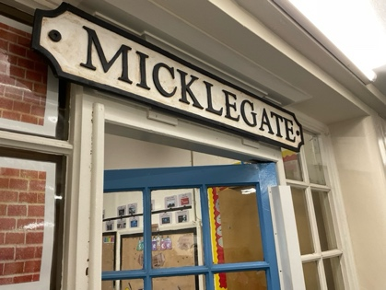A rather cute fun fact about the school would be the class names. Each class is named after a gate, which can be found in York. Since the teachers stay in the same grade and the kids wander, they are assigned a new gate each year. They visit their gate at the beginning of the new school year.

Every Friday, the pupils and teachers get together for assembly in the hall, where they celebrate the pupil of the week (for each grade), birthdays of the week, and attendance certificates (for the top 3 classes). The higher grades (starting at grade 3) also have assembly every Thursday to highlight important topics such as languages, cultures, or self-belief. They show PowerPoints of students, play motivating videos, and let students read poems in their own language.

**Lakeside Tamara, Victoria**

Lakeside Primary Academy is a state school and belongs to the Ebor Academy Trust. The school consists of years one to six, which are split into Key Stage 1 and Key Stage 2. Each year is named after an animal, for example rhinos or turtles. Diversity is embraced as many students come from different backgrounds.

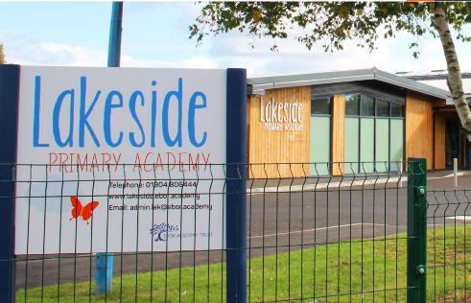They usually start with handwriting, English and math. The snack break for Key Stage 2 (year 3 and older) is at 10:20, and all students go outside to get some fresh air and have a snack. We realized that, contrary to Austria, English kids usually don’t have a lunchbox but rather a small bag filled with little snacks. They are also allowed to use the playground or run on the field while being supervised. They then continue their studies until 12:30 when they go to eat lunch in the dining hall. Some bring their own food, while others get a meal from the cafeteria. After lunch, they continue with music classes, French, history, or PE. Every day around 3 PM, there is an assembly where the whole school meets. Teachers focus especially on rewarding good behavior. In class, well-behaved students will be handed a so-called “raffle ticket” they can put their name on and place into a box. On Friday, the teacher pulls five tickets out of the box. The winners are awarded a small prize like a pencil or a small toy for their good behavior. At the end of each week, one student in each class is chosen as “star of the week.” There are also rewards for attendance—year five won, for instance, a silly hat day.

We assisted in years three and five by either helping students individually and answering their questions or sitting with certain students who needed some extra help getting their work done. We were also able to help by correcting the children’s math, handwriting, or spelling exercises. One feature that is unique to this school was the so-called “forest school.” A few steps away from the building is an area planted with trees and surrounded by a fence. This spot offers highly active children an opportunity to get out of class and do some movement, as they can take an extra break in the afternoon.

As teaching assistants, we always spent our lunchtime in the teachers’ room, which helped us get to know the school as well as the people better. The Lakeside teaching team was extremely welcoming and happy to answer all our questions.

**Park Grove Ena & Sara**

Park Grove Primary Academy is a public school, financed by the Ebor Academy Trust. The school puts a lot of focus on diversity, inclusion, individuality, and creativity. The school building is divided into Key Stage 1, which is on the ground floor, and Key Stage 2, which is on the first floor. Every classroom is named after a colour. In Key Stage 1, that would be red and yellow (often referred to as the orange unit), blue, and green. In Key Stage 2, there are magenta, indigo, lime, maroon, and turquoise. Sara and I stayed with magenta (years 5 and 6) and indigo (years 4 and 5, aged 8-10).

As TAs we were expected to be there between 08:20 and 08:30. The children are brought in at 08:35 and continue working on any unfinished assignments or projects until 09:00. They have English until 10:15, then every class is being read to from a book they have chosen together until 10:30. After a fifteen-minute break they have Math until 12:00. During lunchtime, the children would go outside and play on the field. Meanwhile, us teachers can enjoy an hour-long break in the lunchroom (see timetable in photo beneath). All the teachers at Park Grove are incredibly kind and welcoming and let us listen to their everyday stories about school and private lives. A complementary cup of coffee or tea adds to the charm and makes us feel right at home with them!

After lunch, the children are brought to class by their teacher and read the books they have chosen individually. From 13:15 the schedule varies by day. On some days there would be school assemblies at which they discuss topics such as the eco warriors, music, good work, student representatives, etc.

During our stay we noticed a couple of differences between the Austrian and English educational system. For one, they put much more emphasis on rewarding good behaviour and using positive language when communicating with the children. This creates a safe and compassionate atmosphere that includes everybody. Moreover, as the students advance to the next school level, they get a new teacher every year. Consequently, all the teachers and students get to know each other.

Walking into Park Grove, you can feel a strong sense of community and we were lucky to have been a part of that for a short period of time.

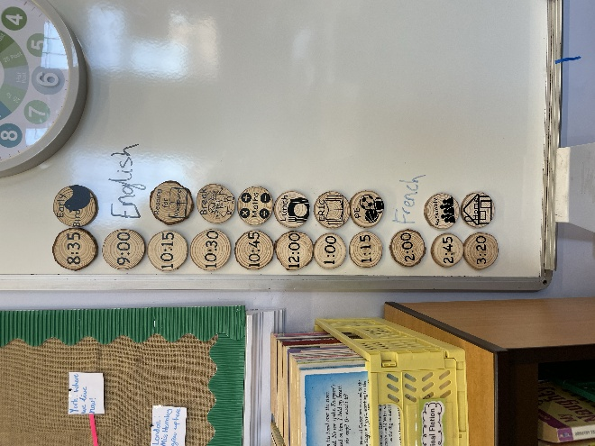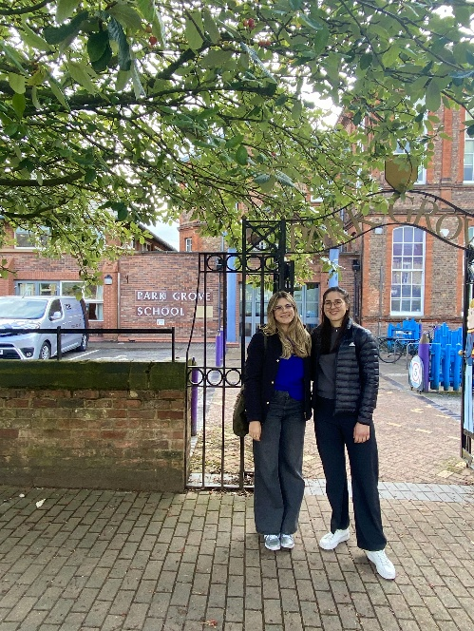

**Robert Wilkinson Primary School (Violetta-Valerie Gallee)**

In Robert Wilkinson Primary School, Doris and I had the opportunity to visit nearly every year group. We visited the Saplings (3–4-year-olds), Reception (4–5-year-olds), Year 1 (5–6-year-olds), Year 2 (6–7-year-olds), Year 4 (8–9-year-olds), Year 5 (9-10-year-olds) and Year 6 (10–11-year-olds) throughout the two weeks and were in a different year every day.

The kids, no matter the age, started school at around 9 am and stayed at school until 3 pm unless they joined an after-school club. From the Saplings until Year 2, they had playtime breaks, where they would get an hour to play with everything the classroom offered. They could use paper, staplers, coloured pencils, toys, figures, cubes, and rings. Lunchtime was set differently from year to year since they tried to avoid student jams. The playtime was cut down to regular breaks starting from Year 3 and continuing to Year 6.

Apart from subjects like English, Maths and PE, they also had Cooking Class, Swimming Class (which ties in with PE) and Spanish. In Cooking Class, they were taught to cook easy and quick meals if they needed to provide food independently. Spanish Class was the foreign language the children were exposed to, so they could get an insight into the language and see if they’d like to continue learning it in secondary school. As for the Swimming Class, the school had a pool built into the building.

I was most impressed by how children were taught how to speak. Instead of learning the alphabet, they learned words and phrases by phonetics and how certain syllables were pronounced. When learning to write, they had a small whiteboard where they could also erase what they had written with their fingers. The children from Saplings to Year 2 were also supposed to sit on the floor when the teacher explained something and worked with the whiteboard. The reasoning for that was to get their full attention.

Another impressive part of the school was that sign language was taught and used to include deaf children. Sign language wasn’t taught in a lesson but by “learning by doing.” Therefore, opportunities like assembly were used to teach the students how words and phrases were signed while talking. The children then were able to join in and mirror the signs the teacher was making at the front.

**Field trip Helene Edinger & Elisa Lietz**

On Sunday, September 22nd, we all went on a trip to the coast of England, organised by Markus Wiesinger.

With a coach, we went to Goathland train station, the station which is used in the first Harry Potter film to represent Hogsmeade train station near Hogwarts. Even though the weather was quite cold and foggy, it was spectacular to watch an old steam locomotive enter the station.

Our next stop was Whitby, where we took our group picture under the jawbones of a blue whale. Wed then went on to explore this town which is very famous for its Fish and Chips. All of the shops say “We have the best Fish and Chips in Whitby”; you have to make up your own mind!

After our visit to Whitby, our coach took us to the quaint village of Robin Hood’s Bay. After a small walk, we found ourselves at the beach where we took lots of photos. Due to the fog, we could not see very far out to sea, but the high cliffs and the beautiful beach alone left us speechless. In Robin Hood’s Bay, we went to a small pub for teatime and ordered Yorkshire Tea. Delicious and perfectly warming for a cold day!

On our way home, we went through Scarborough where we got even more impressions of the coast. Overall, we really enjoyed our field trip, and it was very interesting to see more of North Yorkshire.

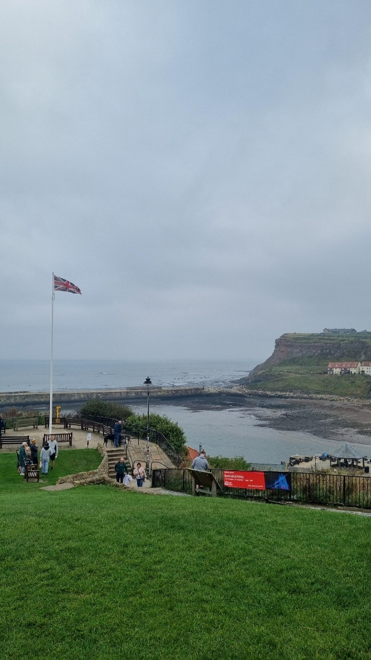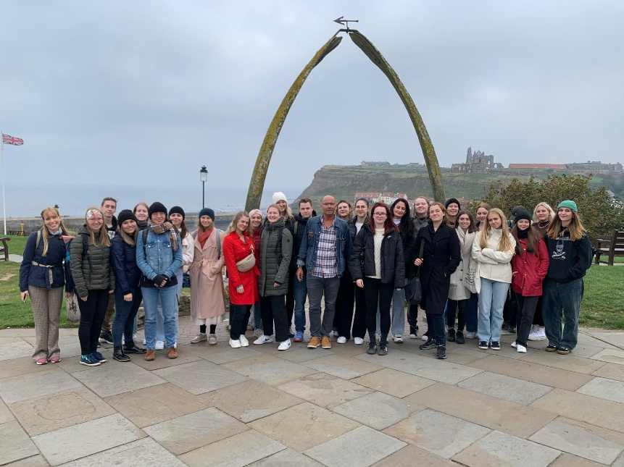

**Things to do / sights in York Jana Czechtizky, Katrin Gürtler, Vanessa Scharinger**

Check out the Jorvik Viking Centre, where you'll get a great overview of York’s history, especially its Viking roots. There was an enthusiastic guide who spent ages explaining Viking weapons and armour, and his outfit was seriously impressive! Another highlight was the York Dungeon, which is perfect if you're in a group. The actors were seriously incredible! Another attraction you cannot miss is the guided chocolate tour at York’s Chocolate Story. An enthusiastic tour guide will introduce you to the history of chocolate and to York’s most famous chocolate brands and chocolate-making families. There are plenty of tastings for you to try out different chocolates, but the best part comes at the end: you get to create your own chocolate lollipop! In the shop downstairs, you also get the opportunity to buy some souvenirs for your loved ones. Also, there are pubs literally everywhere, so why not grab your party to have some drinks and enjoy a karaoke night in the White Horse or have a pub quiz in The Last Drop Inn? We loved it! And wherever you go, don’t forget to ask for student discounts since they’re available almost everywhere.

Are you more of an active person and want to discover the city of York while doing a walk? Why not do a walk on the medieval city walls? This free one-and-a-half-hour walk follows along the city walls of York and lets you discover the city at your own pace. Or how about doing the York Cat Trail? In this free and fun tour, you stroll through York and look for little cat statues that are placed all over the city—can you find them all? But if you’d rather discover York AND learn something about its history from a local, check out one of the many guided tours. There are plenty of different tours to choose from, like a spooky ghost tour taking place in the late evening or a tour that will have you learn about the women who have shaped the history of York.

